 | WORKING WITH ASBESTOS IN BUILDINGS

Essential advice for workers carrying out:  * Building maintenance  * Building repair  * Building refurbishment  * Building services | 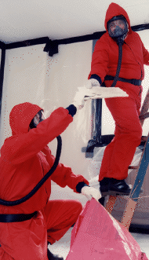
Asbestos: The hidden killer! Are you at risk?

What does this leaflet tell you and who is it for?

This leaflet tells you where you are most likely to find asbestos and how to protect yourself when working with it. It will be particularly useful for anyone involved in building maintenance, repair or refurbish-ment work, for instance, plumbers, carpenters and electricians. It will also be useful to other workers, not normally associated with the building trade; for instance computer installers, cabling installers, fire alarm installers and telecommunications engineers may also disturb asbestos during their work. Safety representatives may also find this leaflet useful.

What does asbestos do?

Breathing in asbestos fibres can eventually lead to a number of diseases. These include:

- asbestosis or fibrosis (scarring) of the lungs;
- lung cancer; and
- mesothelioma, a cancer of the inner lining of the chest wall or abdominal cavity.

There is no cure for asbestos-related diseases.

It is possible that repeated low-level exposures may lead to asbestos-related diseases, although high exposure for long periods is linked more clearly to these illnesses.

Many of those suffering today from asbestos-related diseases worked in the building trades. They were carpenters, joiners, shopfitters, plumbers, electricians, gas service engineers etc. They were exposed to asbestos fibres in their day-to-day work with asbestos materials or because work with asbestos was carried out near them.

What is asbestos?

There are three main types of asbestos - chrysotile, amosite and crocidolite; they are usually called white, brown and blue asbestos respectively. However, they cannot be identified just by their colour.
Blue and brown asbestos (the two most dangerous forms) have not been imported into the UK for nearly 20 years and are now banned by law.

What are the risks from asbestos?

Asbestos-related diseases are currently responsible for about 3000 deaths a year in Britain. There is usually a long delay between first exposure to asbestos and the first symptoms of disease. This can vary between 15 and 60 years. The vast majority of those now dying were exposed to asbestos during the 1950s and 1960s, before the current regulations were introduced.
Work with asbestos can release small fibres into the air. Breathing in these fibres can cause fatal diseases.
But provided the asbestos material is intact and in a position where it cannot be easily damaged, it will not pose a risk to health by releasing fibres into the air.

How does asbestos get into the body?

Although the body will get rid of most of the larger fibres that can enter the nose and mouth, tiny fibres can pass into the lower parts of the lung. They can stay there for years and in some cases work their way through the lung lining. The body naturally gets rid of any asbestos fibres that you might take in with food and water. Asbestos fibres cannot be absorbed through your skin.

What types of buildings are likely to contain asbestos?

Asbestos is likely to be in a building if :

- it was built or refurbished between 1950 and 1980 and particularly;
- if it also has a steel frame; and/or
- it has boilers with thermal insulation.

But you also need to bear in mind that asbestos cement has also been widely used since the 1950s.

Where is asbestos found in buildings?

The use of blue and brown asbestos has been banned since 1985, but many thousands of tonnes were used in buildings in the past. Much of this asbestos is still there and you cannot easily identify it from its appearance.

Its most common uses were:

- sprayed asbestos and asbestos loose packing - generally used as fire breaks in ceiling voids;
- moulded or preformed sprayed coatings and lagging - generally used in thermal insulation of pipes and boilers;
- sprayed asbestos mixed with hydrated asbestos cement - generally used as fire protection in ducts, firebreaks, panels, partitions, soffit boards, ceiling panels and around structural steel work;

- insulating boards used for fire protection, thermal insulation, wall partitions and ducts;
- some ceiling tiles;
- asbestos cement products, which can be compressed into flat or corrugated sheets; corrugated sheets are largely used as roofing and wall cladding; other asbestos cement products include gutters, rainwater pipes and water tanks;
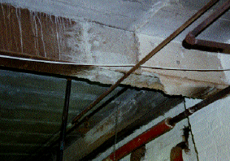
Steelwork coated with asbestos spray for fire protection.
The photograph also shows a section of asbestos lagged pipework. The insulation on both has been partly removed.
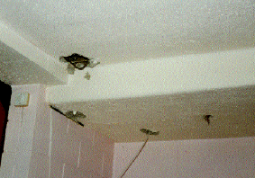
A ceiling coated with asbestos spray, which has been damaged by building work.
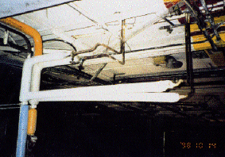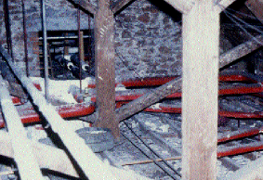
Typical locations where lagging might be found.

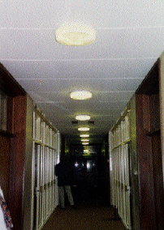A typical asbestos insulation board ceiling.

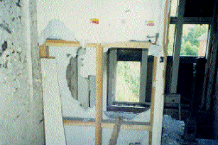A severely damaged wall partition made of asbestos insulating board.

- some reinforced plastics, mastics and sealant;
- millboard, paper and paper products used for the insulation of electrical equipment. Asbestos paper has been used as a fireproof facing on wood fibreboard;
- certain textured coatings, decorative plasters and paints;
- asbestos ropes and cloth.

So what should you do?

Any asbestos materials on site should have been identified before work starts. Work with asbestos insulation, asbestos coatings and asbestos insulating board must normally be carried out by a licensed contractor. Ask 'Has the site been checked for asbestos?' If there is asbestos and you are likely to come into contact with it, get advice from those in charge before you start work. If you are in doubt about whether the material you are working with contains asbestos, STOP WORK, and find out.

If you come across any hidden or dusty materials which you suspect may contain asbestos, stop work and get advice. The person in charge of the job must find out if there is any asbestos on the site or assume that anything that looks like asbestos is asbestos. Identification of asbestos materials is not easy and you can only be sure if it has been tested by a specialist asbestos laboratory.

What should those in charge of
the job do?

They must:
- decide whether or not the work needs to be carried out by a specialist asbestos removal contractor;
- assess the risk to your health from any work that you do, and decide what precautions you need to take;
- prevent your exposure to asbestos or reduce it to the lowest level possible by using suitable controls, banning the use of power tools, dampening the material, enclosing the work and using dust extraction equipment;
- give you information, instruction and training so that you know the risks and the precautions you should take;
- give you clean protective clothing to wear when you work with asbestos;
- make sure you are properly trained to use a mask (respirator) if you need one, you know how to fit it properly and that it's in good working order, clean and stored in a safe place;
- consult the health and safety representative, if there is one, about the control measures.
What can I do to protect myself?

Do:
- keep the asbestos materials damp while you work on them;
- use hand tools;
- use the personal protective equipment given to you, including a respirator (mask);
- clean up as you go, don't let waste pile up;
- clear up asbestos dust using a special 'Type H' vacuum cleaner or damp cloths; /li>
- wash your hands and face when you take a break, and at the end of the day's work;
- put asbestos waste in suitable sealed container. You can use a heavy duty polythene bag, put it in a second bag and label it to show that it contains asbestos (remember asbestos waste needs to be taken to a licensed tip).
Don't:
- use power tools, they create more dust;
- take home overalls you have worn while working with asbestos to wash;
- eat or drink in the work area;
- smoke - the risk of cancer from asbestos is higher among smokers.

DON'T FORGET

Be alert at all times to the dangers of working with old materials that may contain asbestos. If you come across asbestos - stop work and tell your supervisor. Avoid exposure to all dust. Follow the advice in this leaflet and protect your health and that of your workmates. Encourage them to do the same.
More information

You can also find out more about working with asbestos from your safety representative, the nearest office of the Health and Safety Executive, or your Local Authority Environmental Health Department, which is listed in your telephone directory.

HSE pocket card
Asbestos alert: Workers' card for building maintenance, repair and refurbishment workers INDG188p 1995 HSE Books
HSE priced and free publications are available by mail order from HSE Books, PO Box 1999, Sudbury, Suffolk CO10 6FS. Tel: 01787 881165 Fax: 01787 313995.
HSE priced publications are also available from good booksellers.
For other enquiries ring HSE's InfoLine Tel: 0541 545500, or write to HSE's Information Centre, Broad Lane, Sheffield S3 7HQ.
This leaflet is available in priced packs of 10,
ISBN 0 7176 1697 5, from HSE Books.
This leaflet tells you where you are most likely to find asbestos and how to protect yourself when working with it. It will be particuarly useful for anyone involved in building maintenance, repair or refurbishment work, for instance, plumbers,carpenters and electricians. It will also be useful to other workers, not normally associated with the building trade; for instance computer installers, cabling installers, fire alarm installers and telecommunications engineers may also disturb asbestos during their work. Safety representatives may also find this leaflet useful.
This leaflet contains notes on good practice which are not compulsory but which you may find helpful in considering what you need to do.
This publication may be freely reproduced, except for advertising, endorsement or commercial purposes. The information is current at 4/99. Please acknowledge the source as HSE.
Printed and published by the Health and Safety Executive INDG289 04/99 C750

